During WWI the United States as well as almost every other nation involved in the war participated in propaganda advertising to garner (gain) support for the war effort. Propaganda posters, postcards, billboards, movie reels and many other forms of media tried to encourage the people to participate in the war effort in some form or fashion. Propaganda art usually only outlines some of the facts in order to make a point.

Wartime Propaganda
In April 1917 Wilson formed the committee on Public Information (CPI) to promote public backing for the war, a critical task given the lack of a strong national consensus on American participation. This government propaganda agency, headed by the journalist George Creel, acted as a magnet for progressive reformers and muckraking journalists such as Ida Tarbell. Professing lofty goals such as educating citizens about democracy, promoting national unity, Americanizing immigrants, and breaking down the isolation of rural life, the committee also indirectly acted as a nationalizing force by promoting the development of a common ideology.

The CPI touched the life of practically every American during World War I. It distributed 75 million pieces of patriotic literature. At local movie theatres before the feature presentation (which sometimes was a CPI-supported film such as The Hun Within or Pershing’s Crusaders), a volunteer called a “four-minute man” made a short speech supporting the war. Those speeches reached an audience estimated at more than 300 million – three times the population of the United States at the time. But the CPI sometimes went too far. In early 1918, for example, it encouraged speakers to use inflammatory stories of alleged German atrocities, such as rapes and murders of innocent citizens, to build support for the war effort.

WHAT YOU NEED TO DO:
Create propaganda poster that would have appeared at the post office, grocery store, bank or any other public place during WWI. When creating the poster consider the following:
Color: Is it patriotic or just colorful and eye catching?
Words: Who is the poster speaking to…rich intellectuals, small children, or someone in between.
Symbols: Are there any symbols that mean or stand for other things. (e.g. an eagle is a symbol of freedom)
Message: Simple……..what is it going to say?
Audience: Who are you addressing in your poster? Who do you want to be reading this poster?
Purpose: Which branch of the military or government agency is this poster created to support?

Propaganda has many forms.
1. Simplification- The use of a slogan
2. Emotional Appeal- Can call on both negative or positive emotions.
3. Myth Appeal- Using myths or treasured memories to support a value.
4. Name Calling- The use of names when referring to groups or individuals (usually negative)
5. Glittering Generalities- The use of adjectives to describe in a positive way- Makes the product,
event, person sound better then they are.
6. Testimonial- The use of an important person to testify to the importance of the product, event, or
person.
7. Normal Person Testimonial- The use of common language "Normal Folk" to describe the product,
event or person.
8. Band Wagon- The use of "Everybody's doing it" so you should to.
9. Transfer- To transfer one idea to another
10. Case Making- The use of "facts" to build a case for your point
HOW TO CREATE YOUR POSTER:
You should start by briefly answering the questions above (jot them down if you need to). After you have decided what your topic will be please start by using one of two programs on the computers: Microsoft Word or Microsoft Publisher. You will need to use the program you are most familiar with so you don’t waste time.

When you have decided your topic you need to open a blank document and begin building your propaganda poster. Please make sure that you have both words and some sort of image. Clip Art, Google Images as well as other resources can be used to collect images but please make sure that they are pertinent to the topic and theme of the poster.

REQUIREMENTS:
- Must work by yourself to complete the poster.
- Must contain at least 1 image.
- Must contain a reference to a branch of the military or a government agency.
- Must contain correct information about WWI. (1914-1918)

WW1 Propaganda Poster Topics:

- Liberty Bonds which encouraged public support for the war effort.

- Food Administration created in August 1917 by Stanford University trained engineer Herbert Hoover.

- War Industries Board – the central agency for mobilizing wartime industry.

- United States Employment Service which placed 4 million workers in war jobs.

- Women and the war effort – how did women take advantage of the wartime opportunities? How did they participate in the war?

On the back of the poster should be a mini report about your assigned topic. Your mini report should include the following information:
• Who or what is your topic about?
• An analysis of your own propaganda poster. You should clearly explain the significance your slogan as well as why you included all of the images used.

This mini report should be between 2 and 3 full, well written paragraphs. Preliminary Items to be handed in prior to the creation of your propaganda poster:
1. Rough sketch of poster.
2. Answers to your guiding questions.

Guiding Questions:

1. What topic will your poster be about?
2. Describe the poster you sketched in your own words.
3. What is this poster trying to get you to do?
4. How would this poster support the war efforts?
5. What historical facts are covered in this poster? What historical knowledge would the viewer need to fully understand your poster? Explain this part as thoroughly as possible.
6. What type of propaganda technique will you be using in your poster? How will your poster reflect this type of propaganda?

Examples: These are examples for you to use as inspiration. DO NOT COPY THESE POSTERS IN ANY MANNER. Your poster should be your original idea and work.

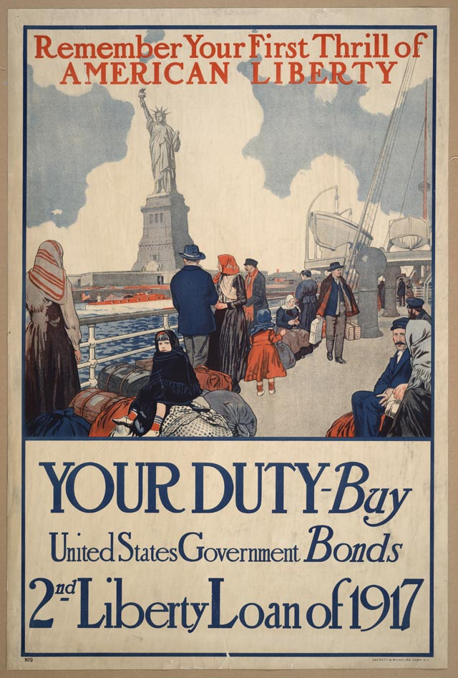 | 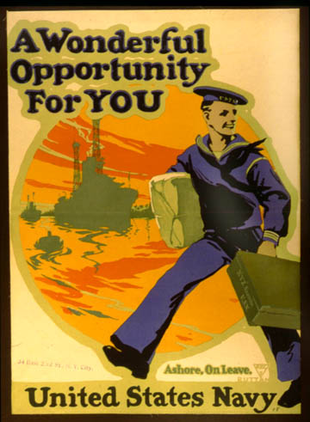 | 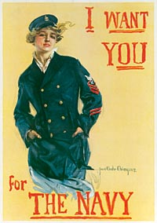
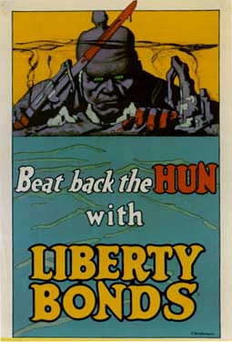 | 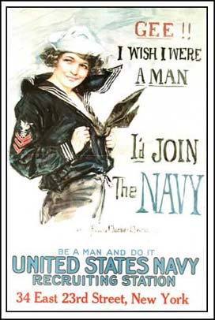 | 